ShopEZ
Full Stack E-Commerce Platform
Project Documentation
Built with MERN Stack
2026

1. Introduction

Project Title
ShopEZ — A Full Stack E-Commerce Web Application

Developer
Solo Developer — Full Stack (Frontend + Backend + Deployment)

Technology Stack
Layer | Technology
Frontend | React.js (Vite), Redux Toolkit, Tailwind CSS
Backend | Node.js, Express.js
Database | MongoDB Atlas (Mongoose)
Authentication | JWT + bcryptjs
Image Storage | Cloudinary
Deployment | Vercel (Frontend) + Render (Backend)

2. Project Overview

Purpose
ShopEZ is a full-featured online shopping platform for both buyers and sellers. Buyers can browse, search, and purchase products. Sellers get a powerful dashboard to manage listings and track business performance.

Key Features
- JWT-based authentication with Buyer and Seller roles
- Product catalog with search, filter by category and price, pagination
- Shopping cart managed with Redux Toolkit
- Secure checkout with shipping address and order placement
- Order tracking and confirmation for buyers
- Seller dashboard with analytics — revenue, orders, top products
- Product management — add, edit, delete listings with image upload
- Customer reviews and star ratings
- Cloudinary integration for persistent image storage
- Fully responsive white and blue UI

3. Architecture

Frontend
React.js with Vite, Redux Toolkit for state, React Router DOM v6 for routing, Axios with JWT interceptors.

Backend
Node.js + Express.js MVC pattern. JWT auth middleware, role-based access, Multer + Cloudinary for images, centralized error handling.

Database (MongoDB Atlas)
Collection | Purpose
Users | Accounts with hashed passwords and roles
Products | Listings with seller reference, images, pricing
Orders | Order items, shipping address, status
Reviews | Ratings and comments linked to products

4. Setup Instructions

Prerequisites
- Node.js v18+
- MongoDB Atlas account
- Cloudinary account
- Git

Installation
Clone the repo:
git clone https://github.com/pavan05-sai/Smartbridge-E-commerce-Application.git
Install dependencies:
cd server && npm install
cd ../client && npm install
Server .env:
MONGO_URI=mongodb+srv://<user>:<pass>@cluster.mongodb.net/shopez
JWT_SECRET=your_secret | CLOUDINARY_CLOUD_NAME=xxx
CLOUDINARY_API_KEY=xxx | CLOUDINARY_API_SECRET=xxx
Client .env:
VITE_API_URL=http://localhost:5000

5. Folder Structure

Client
src/ components/ pages/ redux/ services/ styles/

Server
config/ controllers/ middleware/ models/ routes/ server.js

6. Running the Application

Backend
cd server && npm start
Runs at http://localhost:5000

Frontend
cd client && npm run dev
Runs at http://localhost:3000

7. API Documentation

Auth
Method | Endpoint | Access
POST | /api/auth/register | Public
POST | /api/auth/login | Public

Products
Method | Endpoint | Access
GET | /api/products | Public
GET | /api/products/:id | Public
POST | /api/products | Seller
PUT | /api/products/:id | Seller
DELETE | /api/products/:id | Seller

Orders
Method | Endpoint | Access
POST | /api/orders | Buyer
GET | /api/orders/my | Buyer
GET | /api/orders/:id | Buyer

Seller
Method | Endpoint | Access
GET | /api/seller/products | Seller
GET | /api/seller/orders | Seller
PUT | /api/seller/orders/:id/status | Seller
GET | /api/seller/analytics | Seller

8. Authentication
JWT tokens are issued on login and stored in localStorage. Axios interceptors attach the token as Bearer on every request. authMiddleware verifies tokens and roleMiddleware restricts by role.

Feature | Buyer | Seller
Browse Products | Yes | Yes
Add to Cart & Checkout | Yes | No
View Orders | Yes | No
Add Reviews | Yes | No
Manage Products | No | Yes
Seller Dashboard | No | Yes

9. User Interface
Page | Description
Home | Hero, featured products, category filters
Product Listing | Grid, search, filters, pagination
Product Detail | Images, info, Add to Cart, reviews
Cart | Items, qty controls, order summary
Checkout | Shipping form, order summary
Order Confirmation | Success, order ID, items
Login/Register | Auth forms with role toggle
Seller Dashboard | Analytics, orders, product manager

10. Testing
Test Case | Result
User registration (buyer/seller) | Pass
Login with JWT | Pass
Protected route blocked | Pass
Seller product upload | Pass
Cloudinary image persistence | Pass
Add to cart | Pass
Checkout and order placement | Pass
Seller order update | Pass
Review submission | Pass
Search and filter | Pass
Mobile responsive | Pass

11. Screenshots
Live Demo: https://smartbridge-e-commerce-application.vercel.app

Home Page
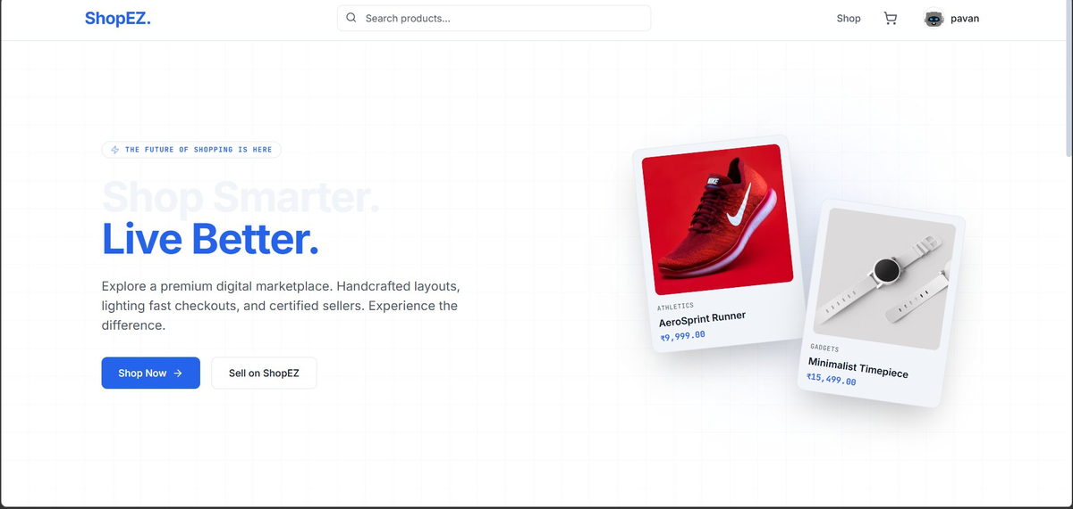
Figure 1: Home Page — Hero section with Shop Now CTA and floating product cards

Register / Login Page
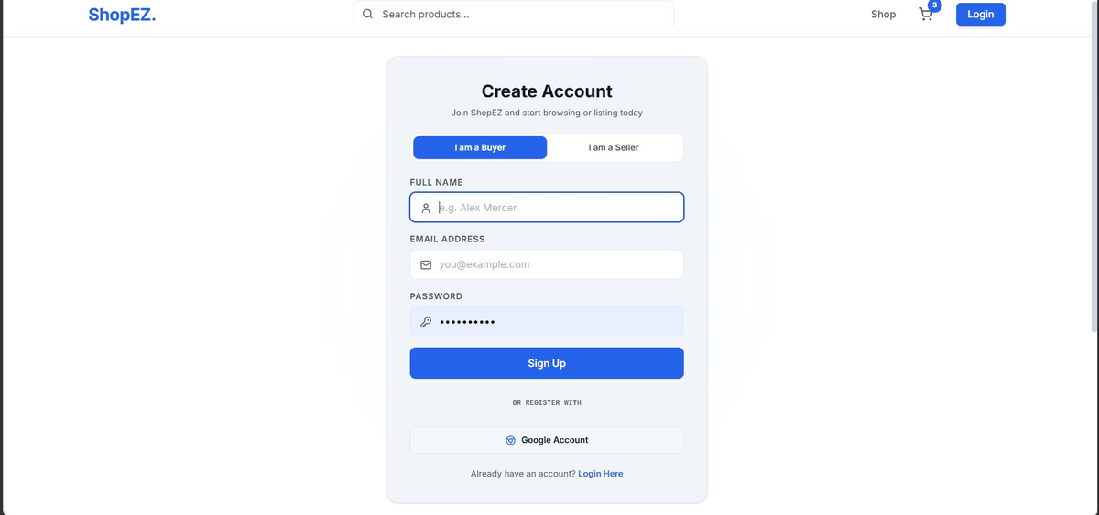
Figure 2: Register Page — Buyer/Seller role toggle with sign up form

Product Listing Page
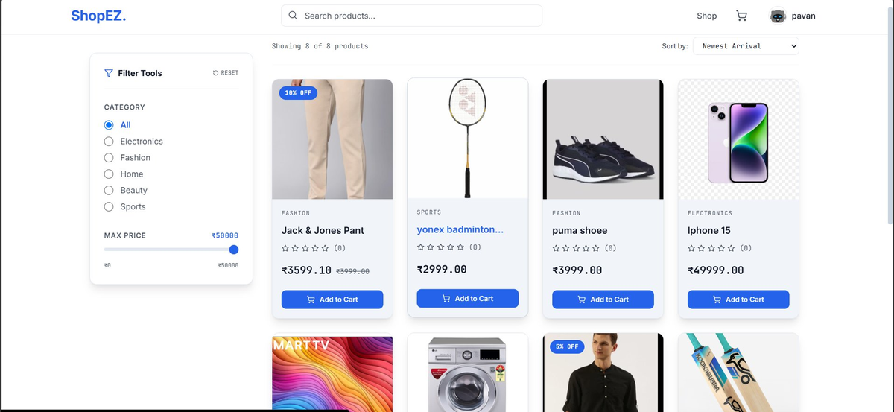
Figure 3: Product Listing — Filters, product grid with Add to Cart

Shopping Cart
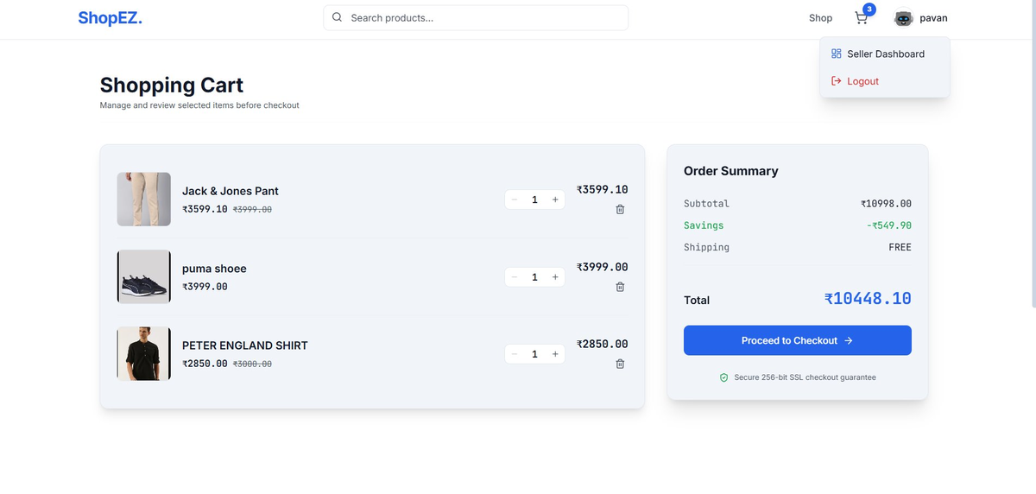
Figure 4: Cart Page — Items, quantity controls, order summary

Seller Dashboard
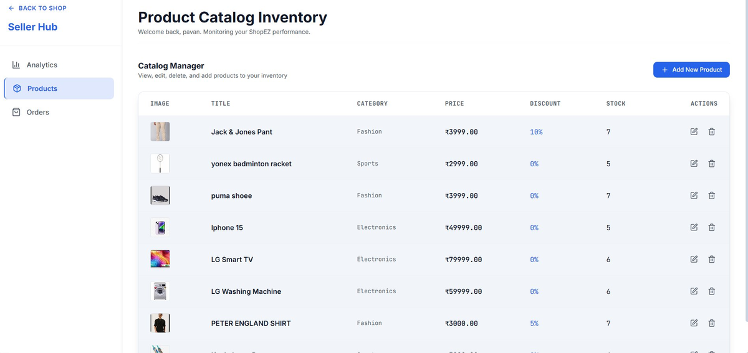
Figure 5: Seller Hub — Product catalog with edit/delete actions

12. Known Issues
- Render free tier cold start delay of 30-60 seconds on first request
- No payment gateway — orders placed without real payment
- No email notifications on order updates
- Single image upload per product

13. Future Enhancements
- Razorpay / Stripe payment integration
- Email notifications for orders
- Wishlist feature for buyers
- Multiple image upload per product
- Admin panel for platform management
- Real-time order tracking with Socket.io
- Google OAuth social login
- PWA support

ShopEZ — MERN Stack Project | 2026

